Who I am “Word Cloud”
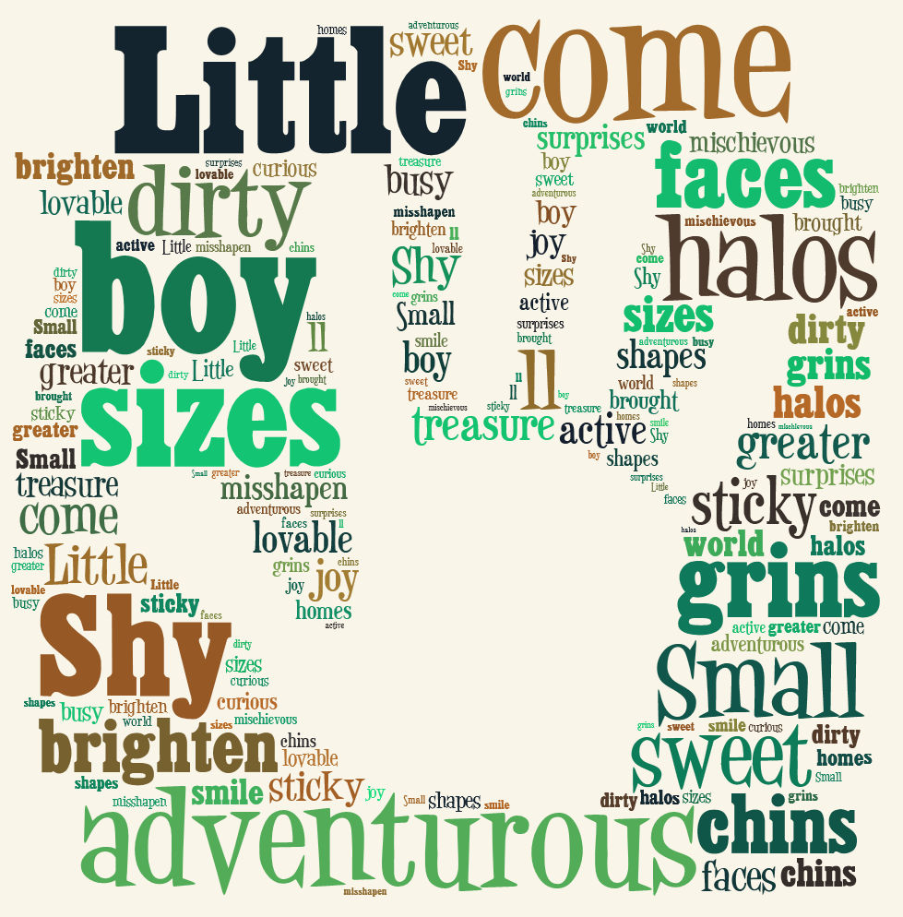
Students will create a simple word cloud about themselves.

Students will type 3 short paragraphs about themselves in word. In this paragraph you will want to talk about the following (Make sure to use words that describe you)

Paragraph 1 - You and your family
Paragraph 2 – You and your hobbies, interests, and likes
Paragraph 3 – What you want to be when you grow up

Open up a word cloud website
- www.tagxedo.com
- www.wordle.net (will need Java installed on your computer to generate)
- www.tagul.com
- www.worditout.com

Copy the paragraphs and paste them in the create window of one of these websites

Manipulate until you have one that you like. Make sure you play around with the size, type and color of text

When you have something that you are happy with you will then save it as a jpeg and then upload it to your website under the “Who am I” page. Print a copy of your word cloud with a copy of the 3 paragraphs and turn them in.

Get a good grade
Paragraph 1 – About you and your family | 5
Paragraph 2 – You and your hobbies, interests, and likes | 5
Paragraph 3 – What you want to be when you grow up | 5
Created a word cloud on one of the above websites | 5
Uploaded the word cloud to their website under the “Who am I” page, publish, print a copy of your paragraphs and word clouds in color an turn in. | 5
 | TOTAL X 2 | 50

Example word clouds using Abraham Lincoln’s “Gettysburg Address”

