Tips and Suggestions for Taking Great Digital Images

The best pictures you take are the pictures that you like the most. However, experts agree that there are a few “rules” or tips to taking photographs that more than a mother could love.

- Use the Rule of Thirds. View your picture as a grid and frame the subject in the outside corners of the grid. This adds visual interest to the image and is pleasing to the eye.

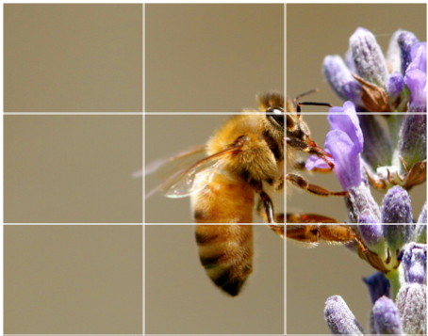

- Look your subject in the eye. Take a photograph of a person, animal, or object from its level.
- Simplify your background. Keeping a photo background free from clutter, shapes, and “noise” will create a cleaner more satisfying image.
- Be a picture director. Avoid taking “snapshots” whenever possible. Instead, photograph your subject in its environment in a way you want. Organize people, rearrange plants, and chase the dog until it holds still. You are in charge of your photograph, not the subject. Pay attention to framing. Nothing ruins a photo faster than distracting elements in the background. Don’t get so focused on the photo’s subject that you ignore what else is going on around them. Watch our for poles, trees and power lines, and look all the way around the edges of the frame, asking “Is this what I really want?”
- Alter your camera angle. Most people, without realizing it, only take horizontal pictures. Take VERTICAL pictures! Change the way you hold your camera and take pictures. With the same subject, practice taking horizontal and vertical shots as well as getting above and below the subject if possible. Also, practice with a wide angle zoom and a close up shot.
- Play with the flash. Digital cameras are smart. Often times, they will take a better picture without the flash than they will with it. Experiment on your own. Using the same subject, take a picture both with and without the flash and see what happens. You will get practice taking pictures and learn the flash range and dynamics of your camera as well. As part of this, watch the light. When taking pictures, be aware of the position of the sun, the type of light (artificial vs. natural), and use sunrise and twilight to your photographic advantage.
- Move in close, and then get closer. Close-ups of most subjects (macro mode on your camera) are generally much more interesting than subjects that are far away. Another great idea: make your subject fill the entire frame of the picture. Change your line of sight. Try kneeling, or even putting the camera on the ground. Or climb a flight of stairs so you’re higher than the subject you’re photographing.
- Look for elements that lead the eyes through the photo. A winding path, a row of telephone poles or even a line of chairs at the beach can serve as elements in a good photo.
- Keep your eyes open for patterns. Interesting photos can be mad of waves and patterns created by drifting snow, a flock of birds fling in formation or pipes stacked at a construction site.
- Look for texture, in the wrinkles of the face or the bark of a tree. Pay attention to detail.
- Cropping brings a photo to life. If you edit photos on the computer, you are no longer limited to standard size.
Camera Angles
Bird’s Eye view – shooting the subject from way above | 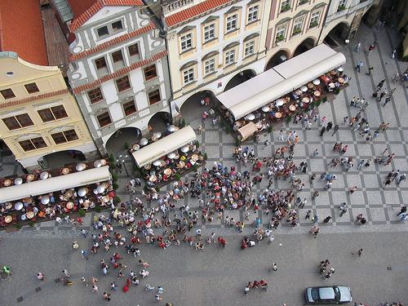 | Worm’s eye view or Low Angle – a shot that is just below the subject, looking up at them. This shot is used to make a subject look larger and more powerful, for example the President is usually shot from a low angle. | 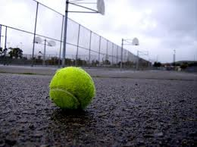
High Angle – a shot that is just above the subject looking down, but not nearly as high as bird’s eye view. This shot can make the subject look or seem smaller and inferior. | 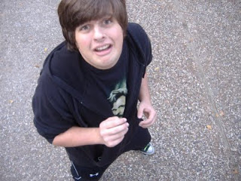 | Canted Angle – a shot that is tilted. Generally used to create the feeling of imbalance. | 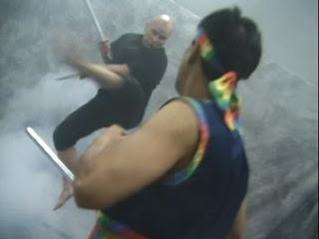

Camera shots

Establishing shot or Extreme Long shot – used to establish a setting or sense of place. Shot is captured very far away from the subject. | 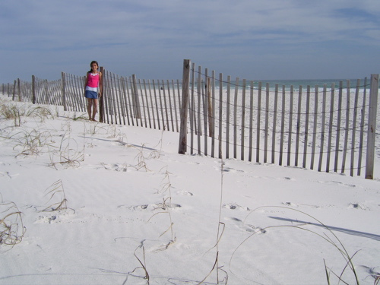 | Long shot – captures all of the subject, this shot generally establishes the size of the subject relative to place. Person head to toe | 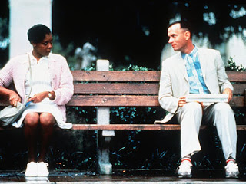
Medium shot – this shot captures half of the subject, generally seen from waist to head for a person. | 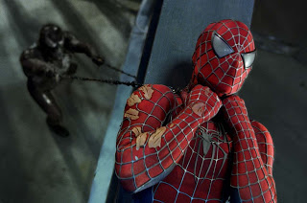 | Close-up shot – this shot focuses in closely on the subject. Used most frequently with people during interviews
 |  | Extreme close up shot – goes in even closer to the subject than the close-up shot and is use to focus on details or to make a more interesting shot | 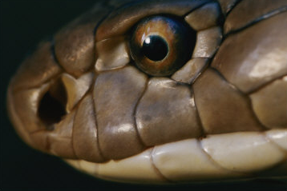

Photograph scavenger hunt

Your assignment is to go out into the field and take pictures. Take a minimum of 30 shots and make sure that you cover the following skills and techniques in as many of your photos as possible.

- Apply the Rule of Thirds to all the photographs you take.
- Take 2 pictures of the same subject, one with flash and one without.
- Take a picture of a person (a portrait) at their eye level.
- Take 2 pictures of the same subject, one with a busy background and one with a simplified background.
- Take 2 pictures of the same subject, one vertical and one horizontal.
- Take a close up picture of the object. Then, move in and take a picture even closer (macro mode on your digital camera).
- Take a picture of some scenery, a good “background” shot.
- Take 2 pictures of the same subject, one into the sun and the other away from the sun.

- Close up of something blue
- Medium shot of someone seated
- Long shot of someone waving
- Close up of something forgotten
- Medium shot of someone or something familiar
- Long shot of something significant
- Extreme close up of something intricate
- Medium shot of tow opposing forces
- Long shot of an empty space
- Low angle of something red
- Close up of a pair of hands
- Canted angle of someone laughing
- Long shot of someone walking away
- Extreme close up of a winking eye
- Bird’s eye shot of your group
- Clock
- Stairs
- Window
- Telephone
- Bike
- Sports field
- Mountain
- Leaf
- Circle
- Triangle
- Rock
- Insect
- Tree
- Teacher
- School

When you have completed the photo take you will import all of the 30 into a slideshow on your website under “My Skills” tab.

