**Photoshop Morphing Assignment**

**Step 1: Setting Up**

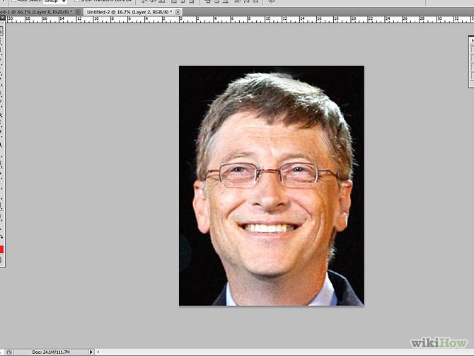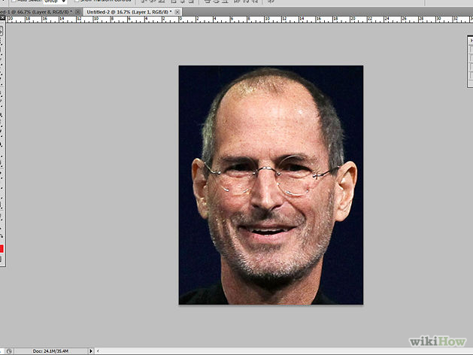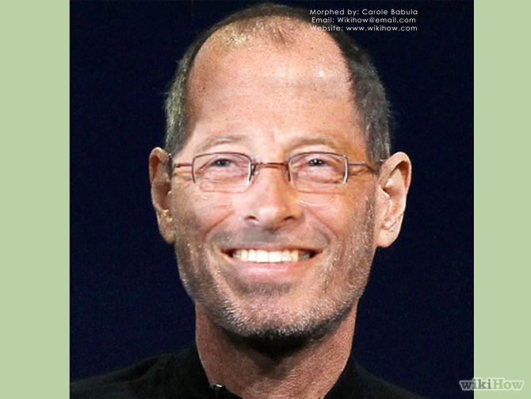

+ =

Steve Jobs Bill Gates New Creepy Guy

1. **Open Photoshop.** Also open the first photo (here it is of Steve Jobs).
2. **Open the second photo.** In this case, it's of Bill Gates.

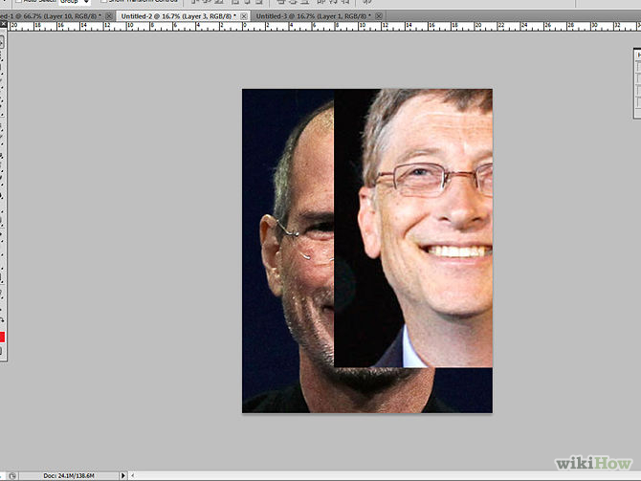

**Step 2: Layering the Image**

1. **Use the rectangular marquee tool to drag over the image and select the face area precisely.** After selection, press CTRL + C on your Keyboard
2. **Go to the first image (Steve Jobs) and press CTRL + V to paste the second photo (of Bill Gates).** Transform it to a smaller size by pressing CTRL + T. Drag it through the corners after transformation to make it proportional. Press enter to apply the size/transformation.

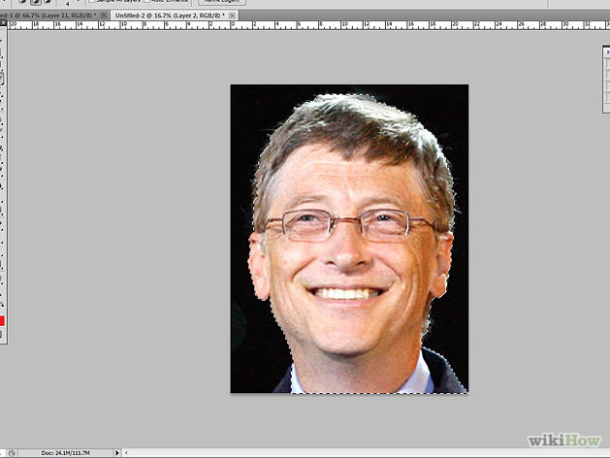

1. **Select the magic wand tool.** Then select the background by holding shift (otherwise it will only select some parts at the one time). Press delete, and it will delete the background, then retouch the image with the eraser, adding a little sharpness.

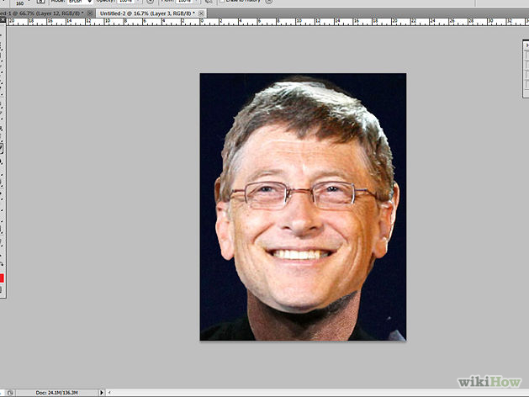

1. **Set the excised image in front of the first photo (Steve Jobs's face).** Use the move tool to move it, then transform it again to set it perfectly before the face of the first photo (Steve Jobs).
2. **In the layers window, double click the first photo (Steve Jobs) layer.** Click OK. Align the Steve Jobs layer after the Bill Gates layer. There should not be any 'Lock' icon on the Steve Jobs layer; if so, unlock by double clicking or unlock using the button above.

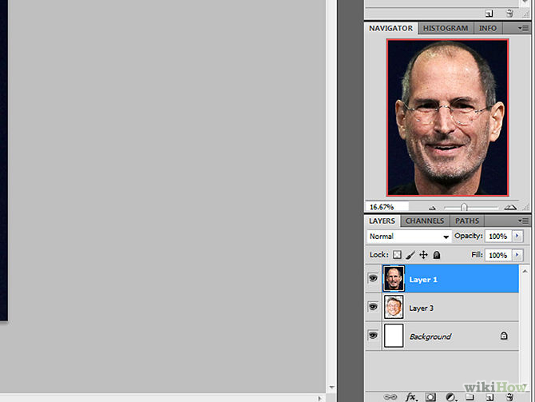

**Step 3: Making Adjustments**

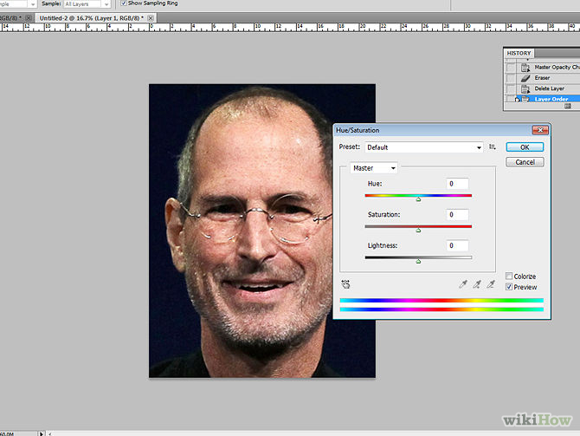

1. **Go to Image > Adjustments> Hue/Saturation.** Adjust the hue and saturation of the first image (Steve Jobs), to make it appear similar to the hue/saturation of the second photo (Bill Gates). This is basically a touch-up process. If the saturation of the first image (Steve Jobs) is markedly different from the saturation of the second image (Bill Gates), th morphing will look like a cartoon and clearly edited, so it requires deft manual fixing to make it look like a real face.

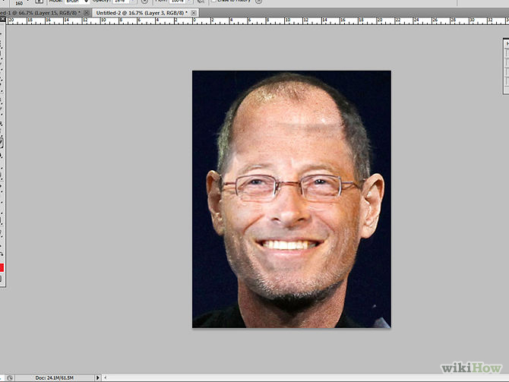

1. **Erase some parts of face from the first image (Steve Jobs) to bring forth the second image (Bill Gates).** Only erase some parts, not the full face. For instance, it's recommended that you only adjust the eyes, nose, lips and hair features. This step is an important stage of morphing successfully.

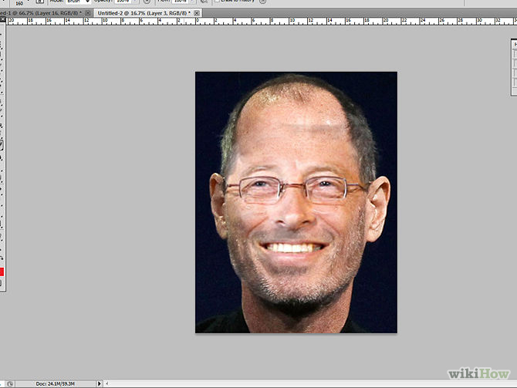

**Step 4: Morphing**

1. **Try to move the second image (Bill Gates) down a little bit to set it perfectly for the morph.** Use the clone stamp tool to retouch some parts again and use the erase tool for any required correction.
2. **You're done.** The new image features a totally morphed image of two people, creating someone new.
3. **Completed.** Here is how your final version should appear.

Morphing can also be done by taking parts of other faces and morphing them onto another. This is done the same way as shown above but by cutting out the parts with the lasso tool. Placing and transforming them and then blending them together.

For the Morphing assignment you will need to create a final piece that includes the following.



|  |  |  |
| --- | --- | --- |
| **PS Facial Morphing requirements** | | |
| Chose an interesting background | 2 |  |
| Image is well adjusted with natural transitions from one morph to the next | 2 |  |
| Morph includes 5 different people | 2 |  |
| The final document created in Word shows how the final 5 people are included in the final image. | 2 |  |
| The final document includes a small narration about the artwork (a short story) |  |  |
| Work is saved as a large jpeg (larger than 1100 x 1200) | 2 |  |
| Clear (not pixelated) | 2 |  |
| Smooth blending (no cookie monster bites or fake smears) | 2 |  |
| Creativity (Unique/ Good Ideas) | 3 |  |
| Craftsmanship (not sloppy) | 3 |  |
| Participation – Used time wisely in class | 3 |  |
|  | Total x 4 |  |
|  |  | 100 |
| **Extra credit:**  Add a prop that the person in your image interacts with +5 pts (ex. Phone, hat, glasses)  Add something interesting in the background + 5 pts (a sign, tree) |  |  |

