Elements and Principles of Art and Design Due
Design is the arrangement of the elements of art in a composition.

Elements - The elements of art are the tools artists use to create a piece of art.
Color
Line
Value
Shape
Form
Space
Texture
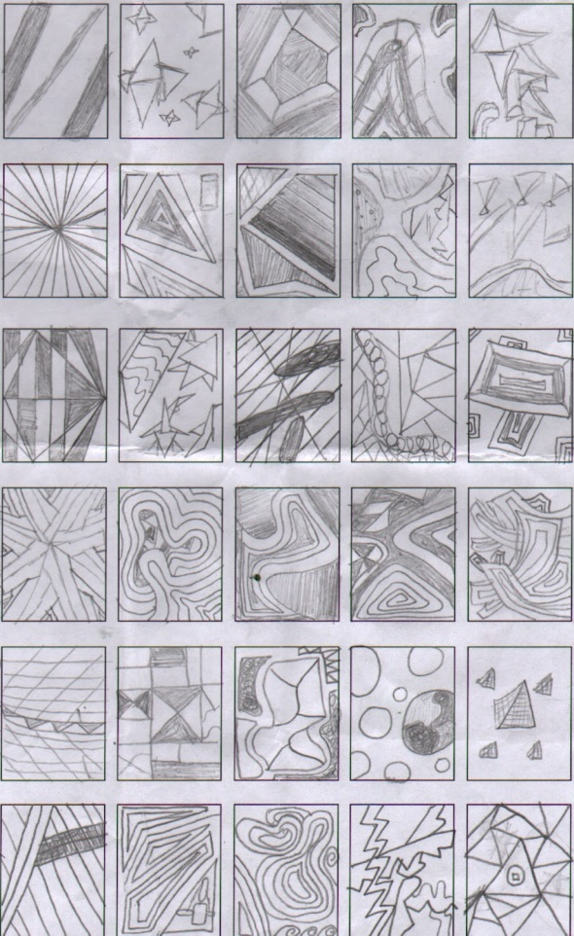
Artists manipulate the elements to achieve a desired effect. An element may dominate a composition or not be used at all. They are the "language" an artist uses to convey meaning.

Principles – The principles of design are how the artist uses the elements of art together
Balance
Variety
Unity/Harmony
Emphasis
Proportion
Movement
Rhythm/Repetition
Artists use these to varying degrees to control and order the elements of art. Principles can overlap or oppose others, while others are seen as more relevant than others.

Take a 12x18 sheet of paper and fold it 8 across and 8 down (64 squares
Title the squares down starting with the second square with the elements
Title the squares across starting with the second square with the principles

Examples:

- Fold paper
- Label chart
- In each square student will create a small composition within the square using the element from the left side and the element from above
- Make sure that you are creative
- Make sure that you are neat and not sloppy
Elements and Principles of Design Chart requirements | Point scale | Total
Chart is labeled correctly | 4
Each square is a great composition (planned out artwork) | 5
Student created a small drawing for each element and principle combination | 5
Student used time wisely in class | 3
Creativity (Unique/ Good Ideas) | 4
Craftsmanship (not sloppy) | 4
 | Total x 4 | 100

