Create a Mini Planet Project
What we will learn:
- We made planets
- Resizing an image
- Image proportion
- Image rotation
- Appling filters
- Tweaking and enhancing images
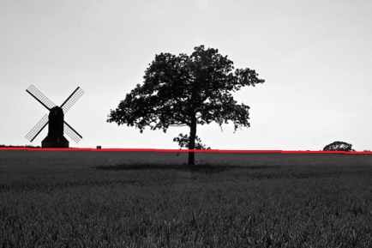
- Take a photo of a landscape (cityscapes or parks work). Make sure that the photo has a strong straight horizon line.
Also make sure that the photo is of good pixel quality.
- Open up the photograph in Photoshop.
- Under “image”, “Adjustment”, “levels” - Adjust the levels of the photo.
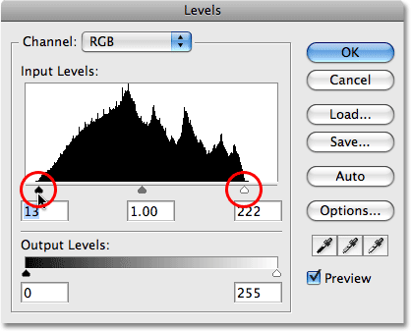
- Now make sure that the photo’s horizon is straight across the picture. Click on “view”, then check “rulers”. At the top of the photo click the ruler and pull down a blue guideline down to the horizon line of your picture. If it is straight pull the line back off of your picture. If it is not, you will need to click on “image”, “image rotation”, “arbitrary” and then adjust one at a time until it is straight and then crop off the uneven edges.
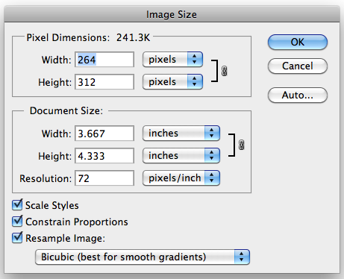
- Now you will need to adjust the photo size to be a perfect square. Click on “Image”, “image size”. Make sure to uncheck the “Constrain proportions”. Then you will make the height and the width the same by adjusting the larger number to be the same as the smaller number.

- Now that the image is square you will then need to flip the image upside down. Click on “image”, then “image rotation” and select rotate “180 degrees.”
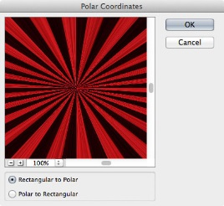
- You can now take your image and turn the picture into a mini planet by clicking on “filter”, then “distort”, then “polar coordinates” Make sure that box rectangular to polar is selected.
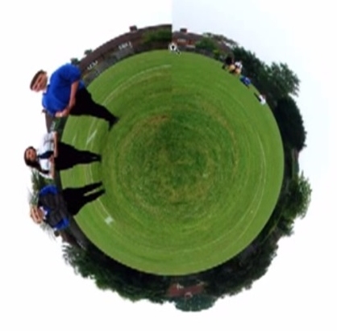
- Your mini planet should look something like this. You will be able to see the seam where photo comes together.

- This will be fixed by cutting a wedge or slice of pizza from somewhere else and sliding it around over the top of the seam and then erasing the part of the sky.
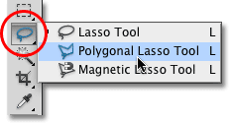
- First select the polygon lasso tool and then click in the center of the planet and then straight out of the planet making a triangle that you would like to copy and rotate.
- Once you have selected your wedge that you think will cover up the seam nicely. You will then need to make a layer with it by clicking “edit”, “layer and then the move tool you will take the pivot mark from the middle of the selection and pull it to the center of the planet. I then go to the outside corner of the selection square and get the rotate handle and slide the slice around to where I am want to cover up the seam. I can then click on the eraser tool and adjust the eraser to a soft eraser and then nibble on the edge of the slice to soften and blend it into the bottom layer. I can also use the blend tool.
- Next I am going to rotate my planet so that I get it at the location that I want it. Before doing that I will merge my two layers by making sure that I can see all the layers, then at the top clicking “layer”, “merge visible”. This will give me just one layer. Then I am ready to rotate the planet by clicking “image”, “image rotation”, “arbitrary” and the put in the degrees that I think that it will need to move.
- The last part of this assignment is to take the planet and to import it into a galaxy. You will need a galaxy photo to import it into.
  - First I want to show you how to search for images that are labeled for reuse and modification.
  - In the google search engine if you click on the settings logo. Then the “advanced search” go to the bottom to “usage rights” and click the drop down menu and select “free to use, share, or modify.” This will allow you to search for images that are free to use without permission.
- Then you may click on the galaxy photo that you would like to use as your background of your mini planet. Copy the image and then open a new document in photoshop and paste into that document. Then take the galaxy image and your mini planet and drag the mini planet into the galaxy image.
- If the image is too big for the galaxy image you will then need to adjust the image size to fit into the galaxy.’
- With your eraser tool (select the eraser to be large enough and soft enough that it will nibble away the edge of the planet creating a glow.
- An extension to the project would be to photograph subjects on green-screen and then embed them onto the planet. You can then create a shadow of the subject as seen below. You could also adjust the colors to look more planet-like.
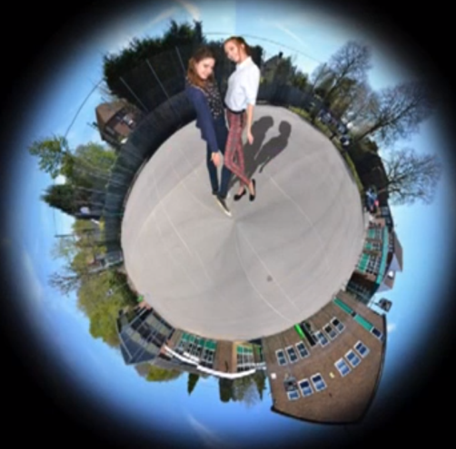

Mini Planet requirements
Used own images- No copyrighted logos or characters | 2
Used levels to adjust image | 2
Resized image correctly | 2
Rotated image correctly | 2
Distorted image with Polar coordinates correctly | 2
Blended the seam of the mini planet | 2
Softly cleaned the edge of their planet | 2
Embedded planet into a galaxy | 2
Creativity (Unique/ Good Ideas) | 3
Craftsmanship (not sloppy) | 3
Participation – Used time wisely in class | 3
 | Total x 4
 |  | 100
Extra credit:
Incorporate person onto the planet +5 pts
Incorporate a shadow of person onto planet + 5 pts

To be graded you need to save a copy as a jpeg and then put the image on your “my skills” page above your photo slideshow on your website.
Extra credit:
Take a photo of the person and cut out the background using the magnetic lasso tool and a soft eraser. Copy that into the mini planet.
To make a shadow for that person, you will take the selection of the person’s body, copy it as another layer and fill it with a shadow gray. Place that layer under the layer of the person and then using the “edit”, “transform”, “skew” to put the shadow going away from your light source on your planet.

