Cheat sheet to command keys

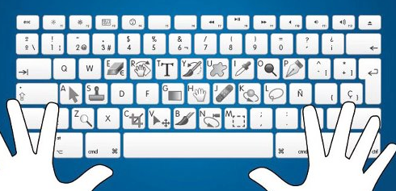
Adobe Photoshop (blue)

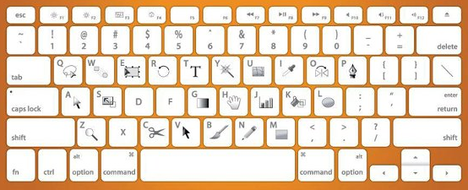
Adobe Illustrator (Orange)

