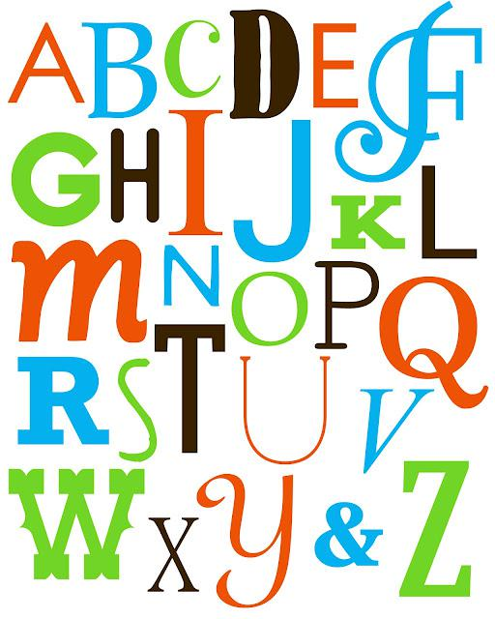**Create an alphabet on Adobe Illustrator**

The english alphabet has been around a very long time. The art of the alphabet has also been around for a long time.

Students will create an alphabet font in Illustrator.

* Create an upper and lower case letter for each of the 26 letters
* All the letters need to be in a the same style
* Open a new document with two art boards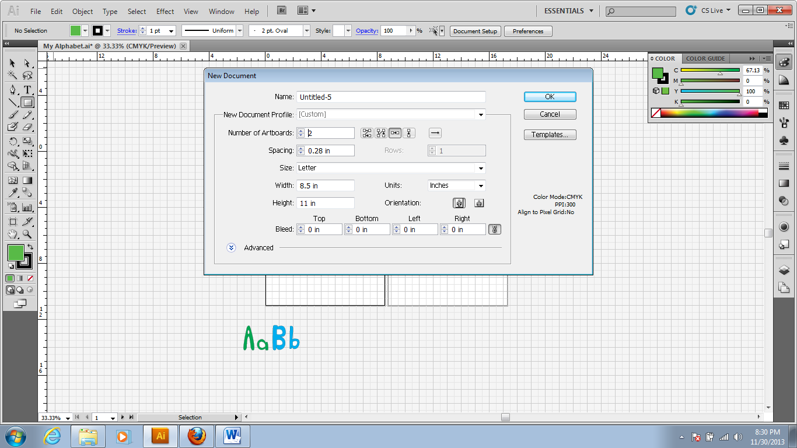
* Set the art boards at 8 ½ x 11 inches
* Set units in inches
* Open up a grid
* Open up rulers
* Using the pen, and selection tools create your font

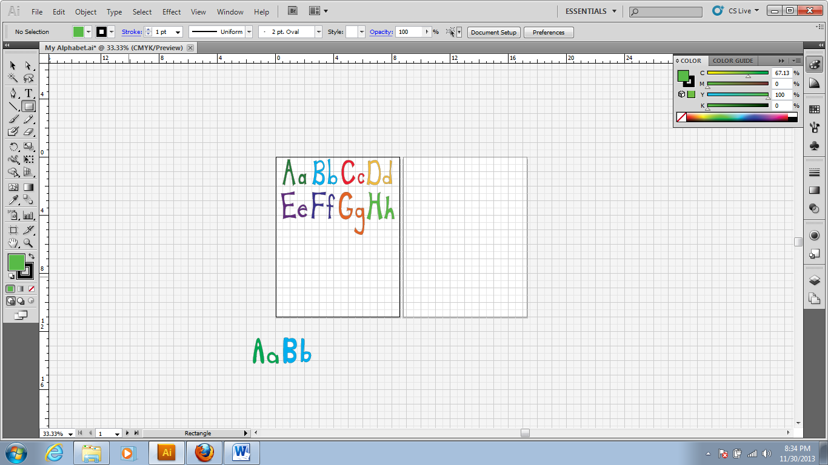

* 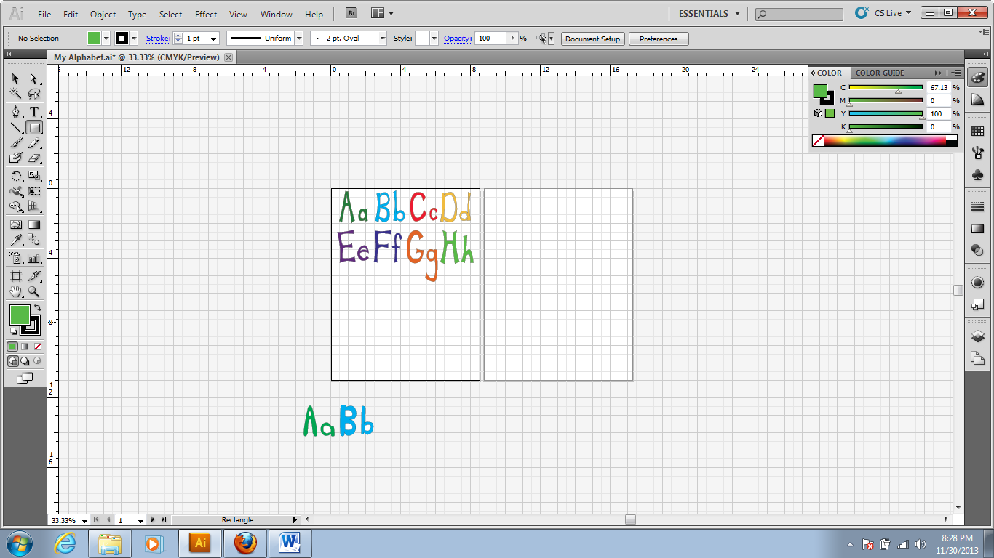Use both art boards – Make sure all of the Uppercase are close in size and all of the lower case are close in size – once one art board is full use the other art board – all 52 characters should fit in the two boards
* For this assignment it is not okay to use the Text tool

|  |  |  |
| --- | --- | --- |
| **Illustrated Alphabet Font requirements** | | |
| Design 26 illustrated upper case letters in AI | 26 |  |
| Design 26 illustrated lower case letters in AI | 26 |  |
| Font and illustrations are consistently similar in style and color | 10 |  |
| Letters are smooth lines, not crooked or awkward | 10 |  |
| Creativity (Unique/ Good Ideas) | 10 |  |
| Craftsmanship (not sloppy) | 10 |  |
| Participation and uses time wisely in class | 8 |  |
| Copy the letters of your name from your font and create your name at the bottom of your second artboard. | 10 |  |
| Print a copy of your illustrated font and turn it in | 10 |  |
| Save a copy of your Illustrated alphabet font as a jpeg and upload it to your web page under the “my skills” tab | 10 |  |
|  | Total | 130 |
| Extra Credit – Student created a symbol or picture and added it to all of their letters | +10 |  |

For 10 extra credit points- Students may choose to include little symbols or clip art in their letters

Example:

<http://www.creativebeacon.com/tips-on-creating-custom-fonts-with-adobe-illustrator/>

<http://www.youtube.com/watch?v=yPzvHgA6MKc>